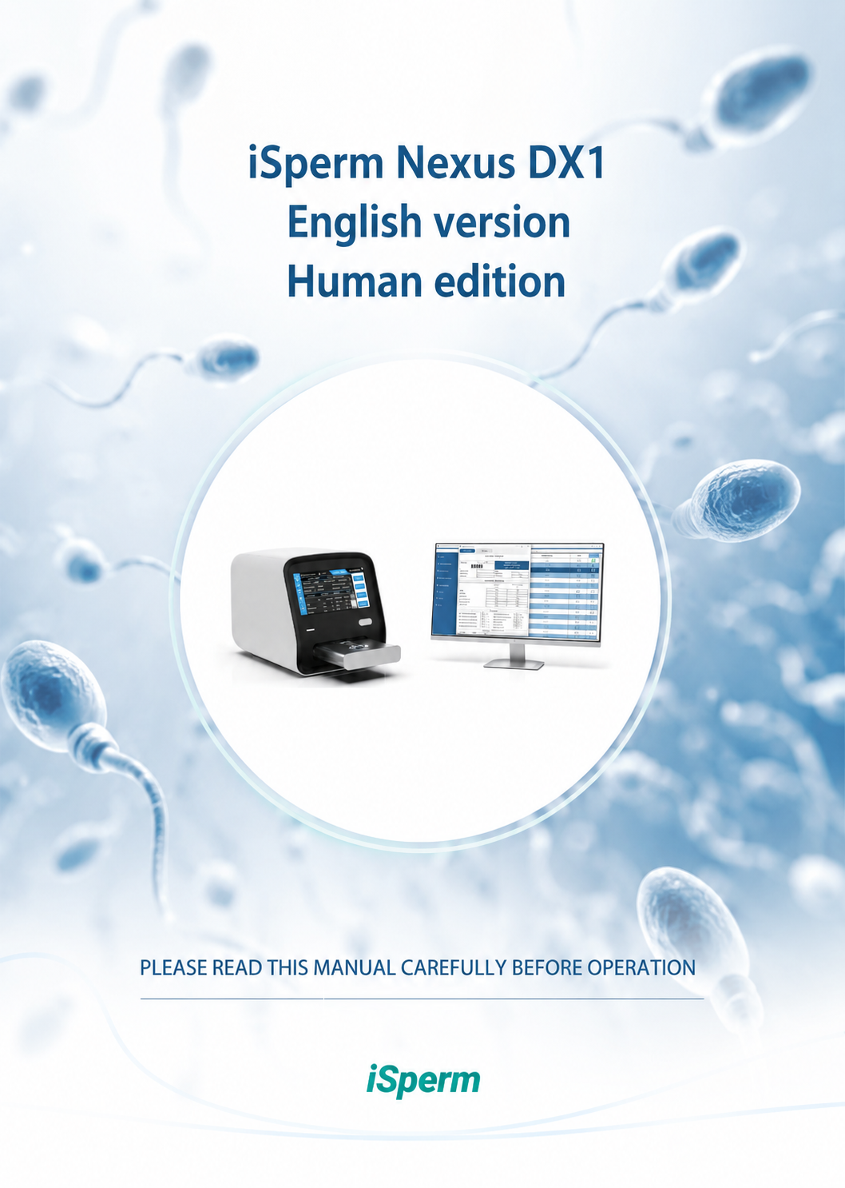

iSperm Nexus DX1 User’s Guide - English Version – HUMAN edition

Version: 1
Language: English
Release date: July 2026

© 2026 iSperm Medical





 | iSperm Medical  www.isperm.com - market@isperm.com

Table of contents

1 Introduction 18
1.1 Product information 18
1.2 Product structure and components 18
1.3 Product applicability 19
1.4 Equipment technique parameter 19
2 Equipment description 20
2.1 Front view 20
2.2 Back view 22
2.3 Other components 23
3 Equipment installation 24
3.1 Equipment opening and sealing 24
3.2 Select proper position 26
3.3 Power source requirement 26
3.4 Connection to the power source 27
3.5 Monitor, keyboard, mouse and other connections 28
3.5.1 Monitor 28
3.5.2 Keyboard + mouse 29
3.5.3 Other cables 30
4 Switch on the equipment 32
4.1 Switch on the SCA SCOPE 32
5 First use 34
5.1 Transport mode 34
5.2 Main screen 39
5.3 Settings 41
5.3.1 General 42
5.3.2 Analysis 49
5.3.3 DataShare 56
5.3.4 IQC 60
5.3.5 Email 61
5.3.6 Demo 62
5.3.7 About 63
5.4 Internal Quality Control (IQC) 64
5.4.1 QC slides 64
5.4.2 Internal Quality Control 65
5.4.3 QC-Beads 67
5.4.4 Notifications 74
6 Standard analysis procedure 76
6.1 Log in 76
6.2 Select the analysis 77
6.3 Select the sample or patient 78
6.4 Load slide and start analysis 88
6.5 Multiple analysis 91
6.6 Finish analysis 92
6.6.1 Sperm Editor 97
6.6.2 Manual modification of an analysis 124
6.7 Results window 147
6.8 Recovery of old sessions 151
6.9 Validate 153
6.9.1 Analysis 154
6.9.2 Sample 154
6.10 Exit system 159
6.11 Diagram 160
7 Advanced options 170
7.1 Maintenance settings 170
7.2 OPEN SCA 173
7.3 NEED HELP window 175
7.3.1 Manuals 175
7.3.2 Protocols 176
7.3.3 Tutorials 177
7.3.4 Send feedback 177
7.3.5 mySCA web 177
7.3.6 Meeting Room 177
7.3.7 Remote Support 177
8 Maintenance 178
8.1 Overview 178
8.2 Maintenance settings 178
8.3 Clean the equipment 178
8.3.1 Clean the surface of equipment 178
8.3.2 Clean the warmed stage 178
8.3.3 Clean the objectives 179
8.4 Equipment maintenance 180
8.4.1 Change fuse 180
8.5 System calibration 180
8.5.1 Micrometer positions calibration 181
8.5.2 Objectives calibration 183
8.6 Prepare SCA SCOPE for transport 186
9 SCA® Configuration Manager 193
9.1 Introduction 193
9.2 Configure connection 194
9.3 General 195
9.4 Patient 196
9.5 DataShare 196
9.5.1 Database 197
9.5.2 Export 197
9.5.3 HL7 198
9.5.4 MedITEX 200
9.6 User 201
9.7 Sample 202
9.7.1 General 203
9.7.2 Default values 204
9.8 Analysis 204
9.8.1 General 205
9.9 Reports 206
9.9.1 General 206
9.9.2 Details 207



Intended use

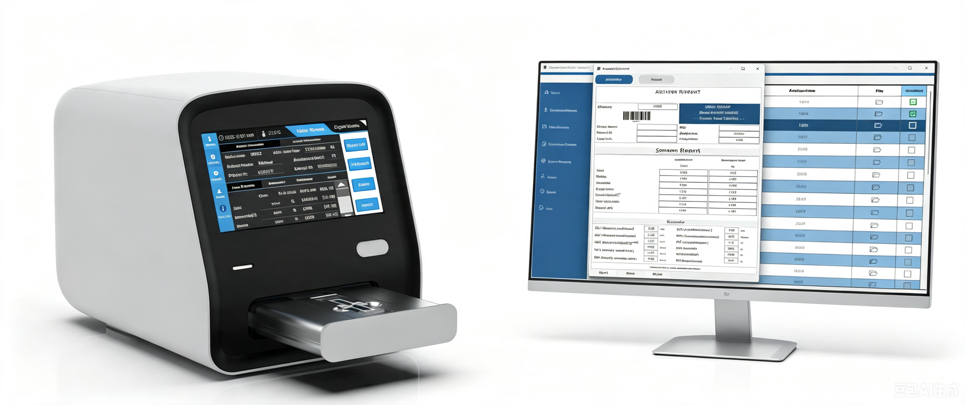

The device is intended for the automated acquisition and processing of microscopic images of in vitro human semen samples.
The device generates structured, image-derived data representing observable characteristics of the samples, to support laboratory-related activities such as method standardization, workflow consistency control, and internal reference purposes.
The device does not provide medical interpretation, is not intended to establish or exclude any clinical condition, and shall not be used as an independent basis for diagnostic or therapeutic decision-making.
The outputs generated by the device are non-decisional and auxiliary in nature, and are intended to be used by qualified professionals in conjunction with other laboratory information and relevant contextual data.

How to use this manual

It’s greatly appreciated you become the user of Nexus Dx1.

To get the best effect, you must be familiar with our equipment and their functions before performing the clinical diagnostic tests.
This manual is the operating guidance of Nexus Dx1 semen analyser, which includes the contents of equipment installation, daily test, quality control and maintenance.
Please, reserve all the packing materials for the use of deposit, transportation and maintenance in the future.
You may contact your distributor if there is any problem.

Warning:
 | Indications must be obeyed, to ensure the normal operation of equipment and correct and real test results.

Symbols on the equipment

 | This means that the labelled item could lead to personal injury and/or damage to the analyser. The symbol is labelled beside the power outlet and some external interface.
 | The symbols for “SERIAL NUMBER”, The serial number shall be after or below the symbol, adjacent to it.
 | The symbol indicates the manufacturer and its address, after which are shown its name and address.
 | The symbol indicates the date of manufacture, after which are shown its manufacture date.
 | The symbol means that the environment of equipment must be damp proof during transport, and equipment must be kept in a dry environment.
 | This means that equipment should handle with care during transportation, so as not to damage it.
 | The symbol means the equipment packaged should not be upended at any time.
 |  | This symbol indicates that when the end-user wishes to discard this product, it must be sent to separate collection facilities for recovery and recycling. By separating this product from other household-type waste, the volume of waste sent to incinerators or land-fills will be reduced and natural resources will thus be conserved.

Warning and safety indications

This equipment is only used for in vitro diagnosis, please carefully read the following warnings before the usage, and strictly obeys them.

Please carefully read the following announcements before using this equipment.

Cut off the power source at once if there are abnormal smells or smokes and pull out the power plug from the outlet. At that moment, you must immediately propose test applications to the distributors and the agents of our company. If it is continuously used under this condition, it may cause fire, electric shock or personnel casualty.
Neither water and reagent nor metal pieces of staple and pin should be dropped into the equipment; otherwise it would lead to short circuit or smoke and fire. If there is something abnormal, cut off the power source at once, and pull out the power plug from the outlet. At that moment, you must immediately propose test applications to the distributors and the agents of our company.
Operators don’t touch the electric circuit inside the equipment, especially wet hands, which may be easier to get electric shock.
Rubber gloves must be put on while maintaining and checking the equipment, and prescriptive tools and spare parts should be used. After finishing the operation, please use disinfecting liquid soap to wash hands.
The used tubes and other equipment should be properly disposed as the medical wastes or infective wastes. If the person is stained with blood, there is possibility of being infected by pathogens.
Power voltage, connection and earthing
Be sure not to insert the plug into the electrical outlet of alternating current over 220v. Otherwise, it may cause fire or electrical shock.
When the equipment is installed, three-core power cable accompanied with the machine must be used, and ensure it is well earthing. Otherwise, it may cause fire or electrical shock.
Be sure not to damage the isolation protection peel of power line. Do not pull the power line with exertion or hang heavy things on it. Otherwise, it may cause broken circuit or short circuit, thus lead to electrical shock or fire.
Power source must be cut off when connect the peripheral equipment. Otherwise, it may cause electrical shock or troubles.

Shelf-Life
Once the device is put into operation, there is a shelf life of 6 years. The 6-year device life-time limit is applicable if the final user chooses NOT to install software updates that may be developed by the constant evolution of technology and incorporation of new clinical tests.

Introduction

Product information
Product name: Nexus Dx1
Model: v.1.0
Product property:
Nexus Dx1 is an automate system intended for the automated acquisition and processing of microscopic images of in vitro human semen samples.:
- Concentration: Calculates the total sperm number of a semen sample and the sperm concentration (M/mL).
- Motility: Calculates the total percentage of motile sperm.
- Morphology: Calculates the total percentage of morphology pattern sperm.
- Round cells pattern: Calculates the concentration of round cells like Non-sperm particles.
After the analysis, the system sends all the results, videos, images and sessions to the Laboratory Information System (LIS), where is possible to check the analysis or print reports.

Product structure and components
Nexus Dx1 is internally composed by:
Optical system
Motorized stage
Warm stage
Digital camera
Computer control system and software

Product applicability
Nexus Dx1 is intended for the automated acquisition and processing of microscopic images of in vitro human semen samples.

Equipment technique parameter
Light source: LED light
Temperature control: From room temperature to 60ºC (37ºC as default)
Interface: HL7 standard protocol
Display: Internal displayer 7 inches
Print: External printer
Work environment: 0ºC to 40ºC; relative humidity<85%
Storage environment: -10ºC to 40ºC; relative humidity<85%
Weight: 7kg
Overall dimensions: 283mm(L)207mm(W)x244mm(H)
Power supply: A.C. 110V/240V, 50Hz/60Hz
Power input: 12V 5A

Equipment description

Front view

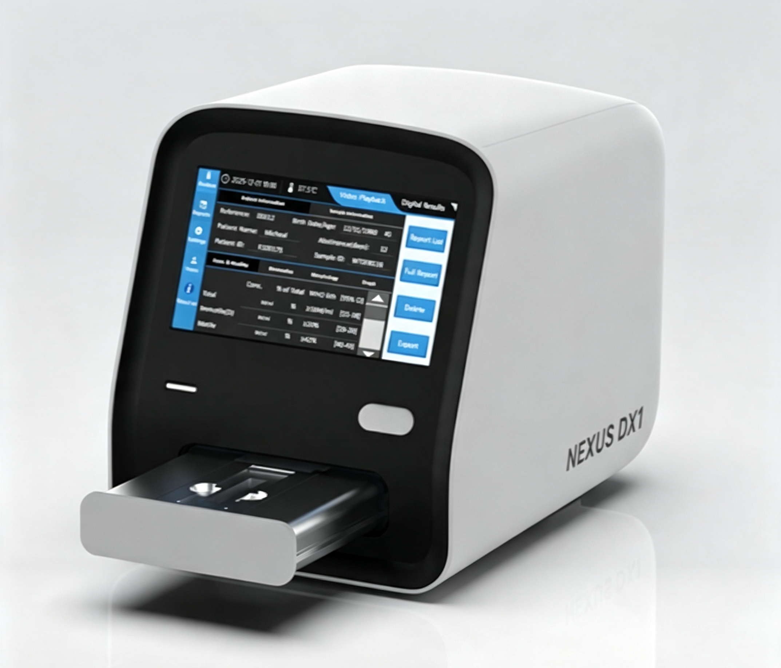

Figure 1. Nexus Dx1 front view
- Indicating lamp 1 (left): Power lamp.
- on if power switch is on.

Figure 2. Power lamp: Power switch is on

- Off if power switch on the rear panel is off.

Figure 3. Power lamp: Power switch is off

- Indicating lamp 2 (right): Functions lamp.
- Green: Always on if the system is ok.

Figure 4. Functions lamp: Load new slides

- Fix red: Be careful, door opening or closing. Warning or problem inside the system.

Figure 5. Functions lamp: Door opening or closing

- Blue: Analysis in progress.

Figure 6. Functions lamp: Analysis in progress

- Door: To load the slides to perform the analysis. The door will open/close automatically.

Back view
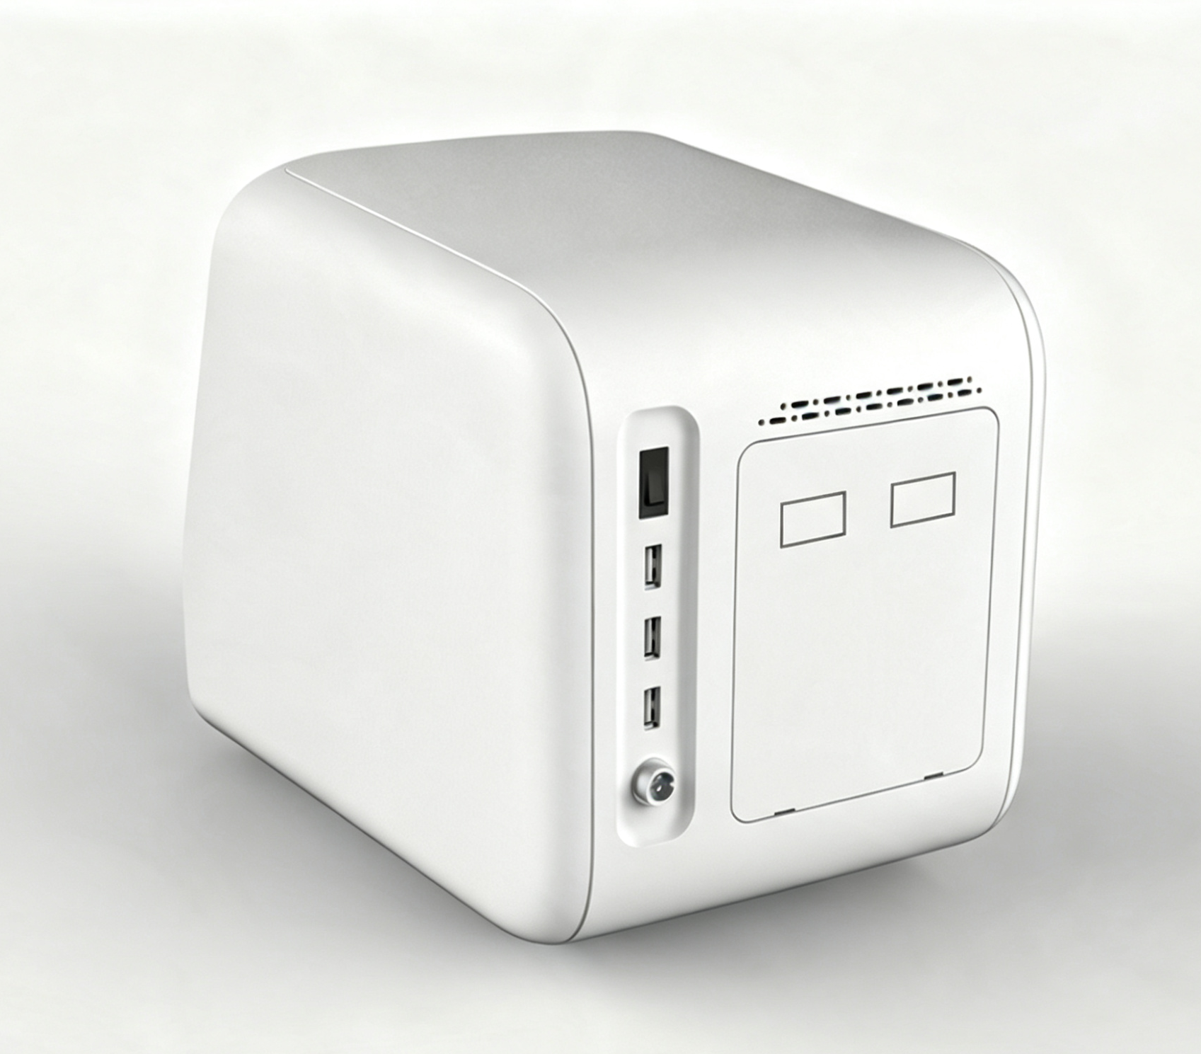

1

4

5

2 3

Figure 7. Nexus Dx1 back view
- Power switch
- PC Monitor connection (Screen Port)
- PC software connection (Data port)
- 3 USB ports. Connect keyboard, mouse, barcode scanner, USB disk
- Power cable

Other components
Nexus Dx1 also includes the following components:
- Barcode scanner wired
- Keyboard + mouse
- USB flash drive (for APP update, Export Reports), FAT32 Only, Device-Specific
- Screen port cable (Mirco USB cable)
- Data port cable (Network RJ45 cable)
- Power Adapter (Input: 100-240V 50/60Hz 1.4A, Output: +12V 5A 60W)

This system is also compatible with any USB keyboard and mouse which is compatible with PC.

Equipment installation

Equipment opening and sealing
- Open the transportation box.

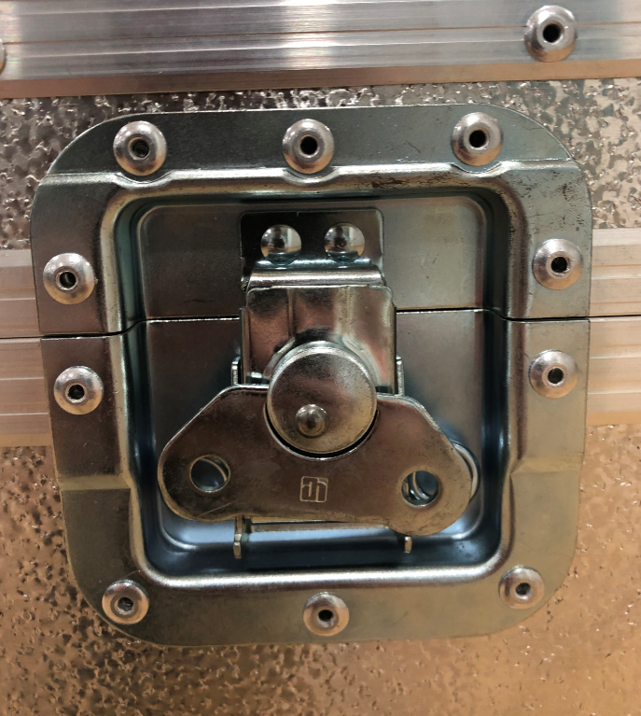

Figure 8. Transportation box lock
- Take off the packing materials and take the equipment out of the package. Be careful: Nexus Dx1 is a heavy equipment. Preserve the packing box and materials well provided that you may need to repack the equipment in the future.

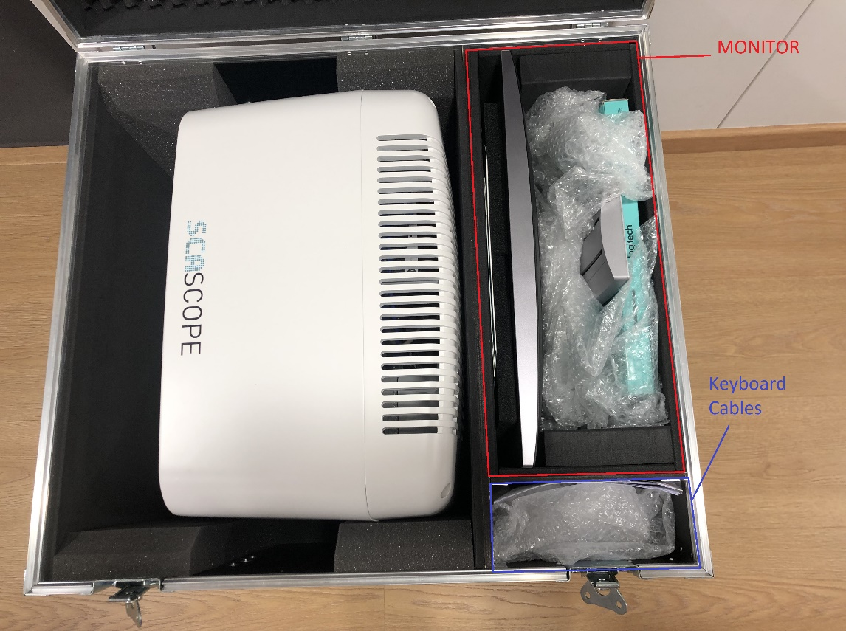

Figure 9. Content of the packing box
- Check the articles inside the package box, and confirm the following stuffs should be included:
- Nexus Dx1 Analyzer
- Keyboard and mouse
- Calibration slide
- User’s manual
- Packing list
- Warranty certificate
- Power line
- QC certificate
- QC slides SCA SCOPE
- USB with information
Note: The product accessories should be in accordance with the packing list. Please contact with the distributor when the accessories are not correct.

Select proper position
Find a place without direct sunshine in your working place. The surface of the selected working table should be flat, with enough space for placing SCA SCOPE and monitor. The anterior edge of equipment should be near to the edge of working table. Avoid comparatively large shake of working table.
Note: The work environment of equipment is that temperature is between 0ºC-40ºC and relative humidity is below 85%.
To guarantee the normal working of equipment, the following places are forbidden to be put on:
- Places with extreme changes of temperature.
- Places near a centrifuge or shaking machines.
- Particularly hot or cold places.
- Places full of dust.
- Places nearer to the electromagnetic devices that produce magnetic field.
- Places with direct sunshine.

Power source requirement
A.C.110V/240V
50Hz/60Hz
60VA

First use

Main screen
- Switch on the Nexus Dx1.
After starting the system, the main screen (7" Built-in LCD Touch Screen) will appear:
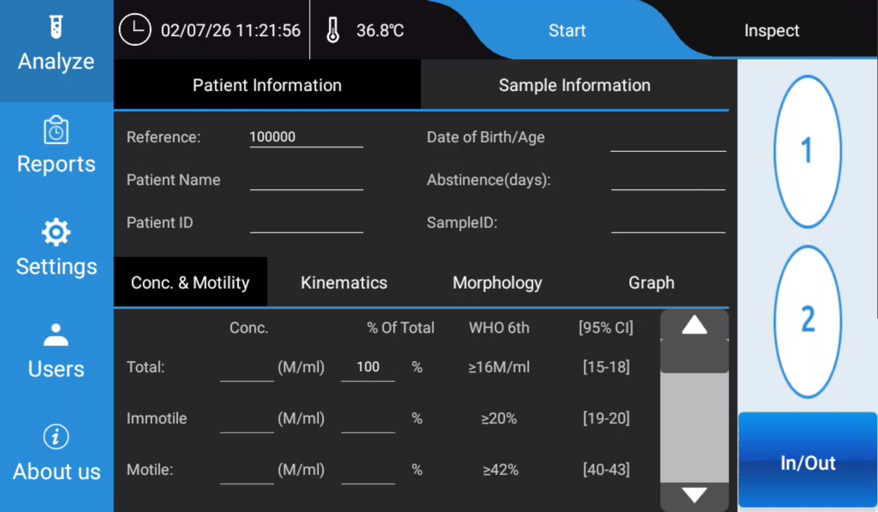

Figure 10. Main screen
Options available:
 | Language selector: Change the system’s language.
 | Power options:  - Shut down: Turn off the system.  - Restart: Turn off the system and restart it automatically.
 | System settings: Access to the system’s configuration options.

Settings
Click the “Settings” button to enter to the system’s configuration menu. The “Settings” button is available at the main screen as well as the “Analysis” screen.

General
In this section, there is the option of Microscopic Fields, setting to adjust the number of imaging fields per chamber. Available selections are 1, 2, or 3. When you pick a value, the system will analyze that many fields within each sample chamber, then calculate an average value from all captured fields.
Using more fields delivers higher test accuracy, though it will take longer to complete analysis.

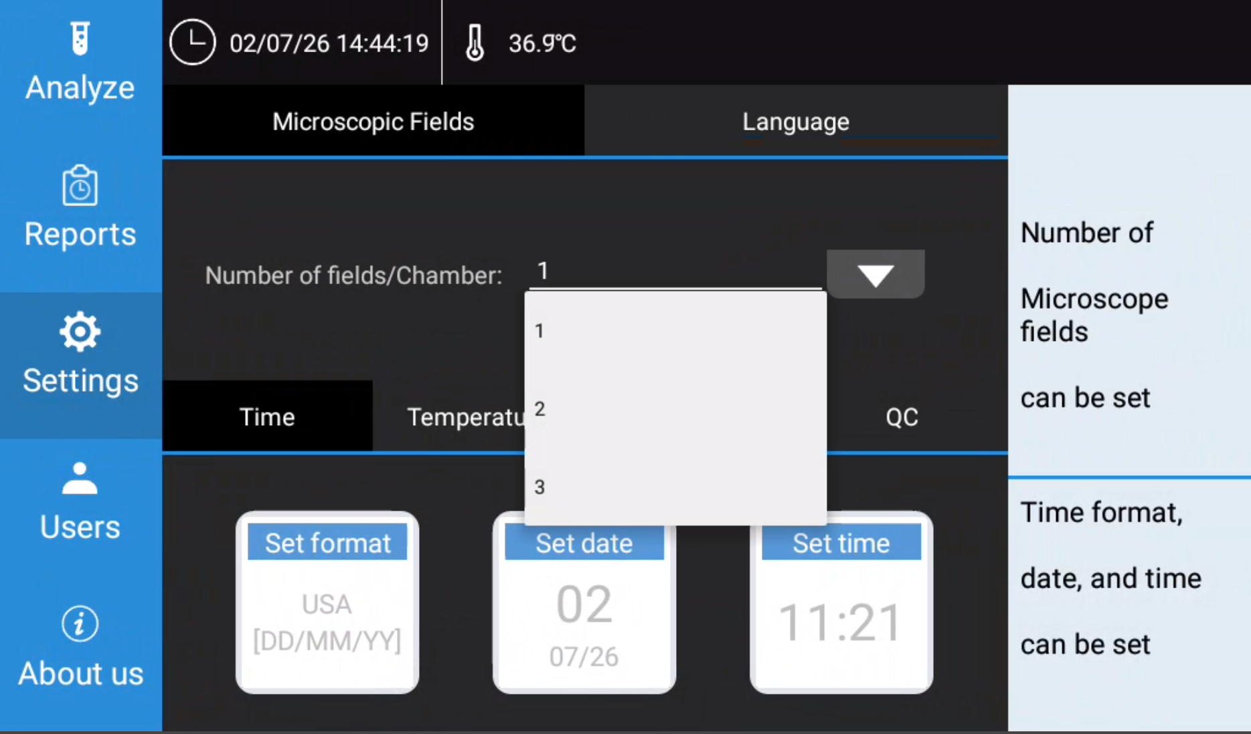

Figure 11. Settings menu/ Microscopic Fields

In this section, there is the option of Language selector: Change the system’s language.

A total of twelve different languages are available for selection in the dropdown menu.
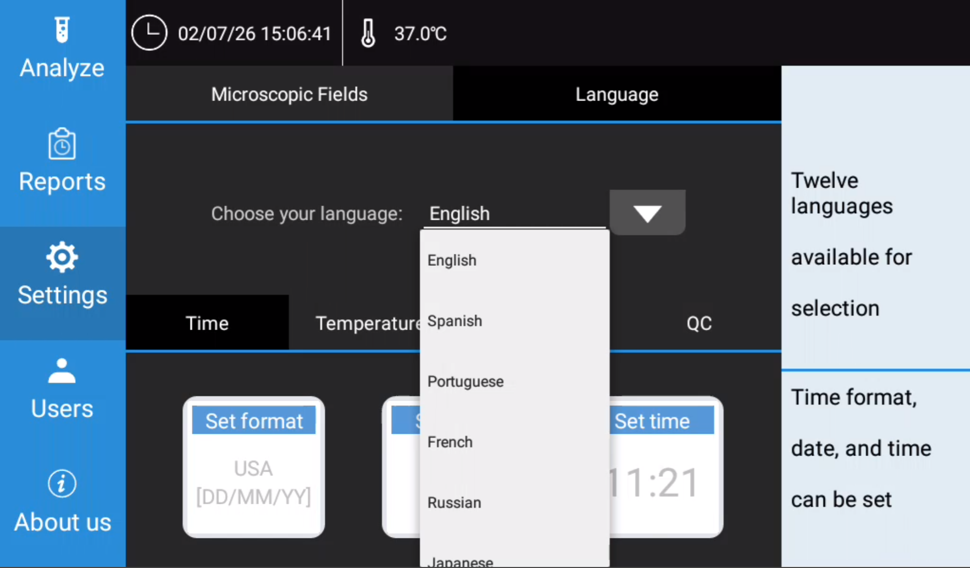

Figure 12. Settings menu/ Language

In this section, there is the option of Time. Time format, date, and time can be set.
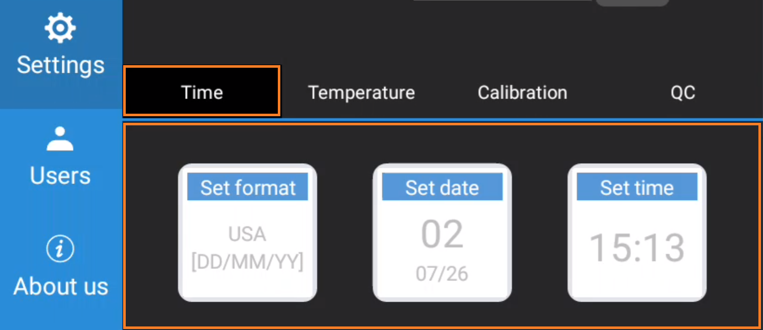

Figure 13. Settings menu/ Time
In time format section, there are two formats available: USA [MM/DD/YY] and Europe [DD/MM/YY].

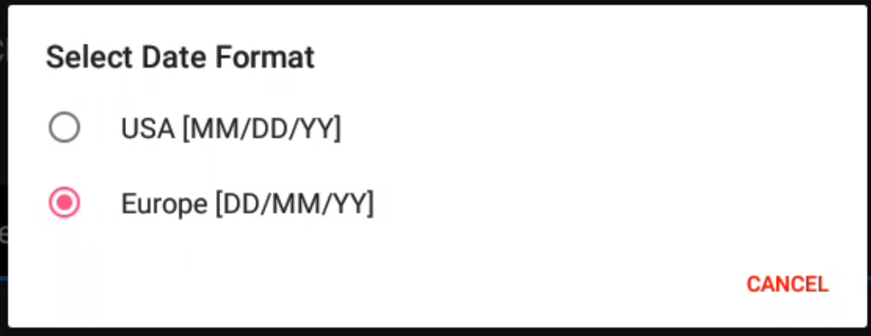

Figure 14. Settings menu/ Time / format

In date section, you can set the system’s current date.

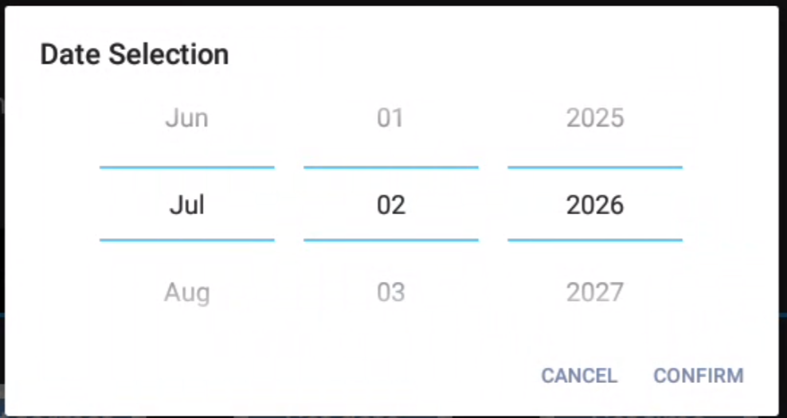

Figure 15. Settings menu/ Time / date
In time section, you can set the system’s current time.

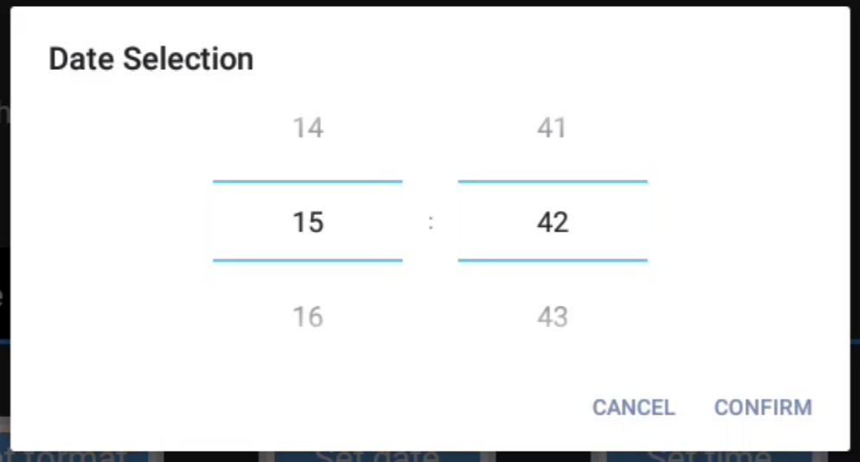

Figure 16. Settings menu/ Time / time

In Temperature section, the temperature of the platform can be set, the range is 35°C ~ 40°C.

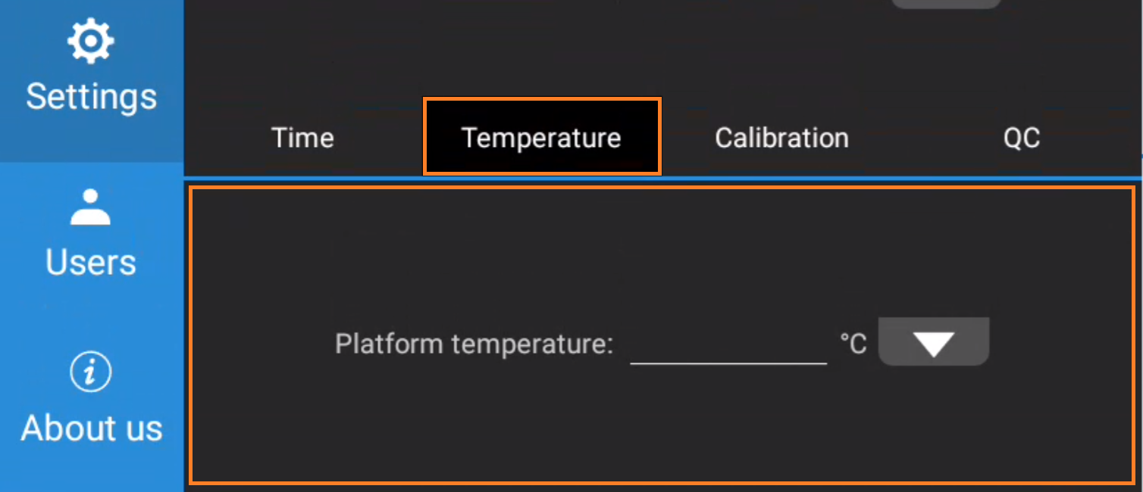

Figure 17. Settings menu/ Temperature
In Calibration section, the calibration factor of concentration and motility can be set. More information at Calibration guide.

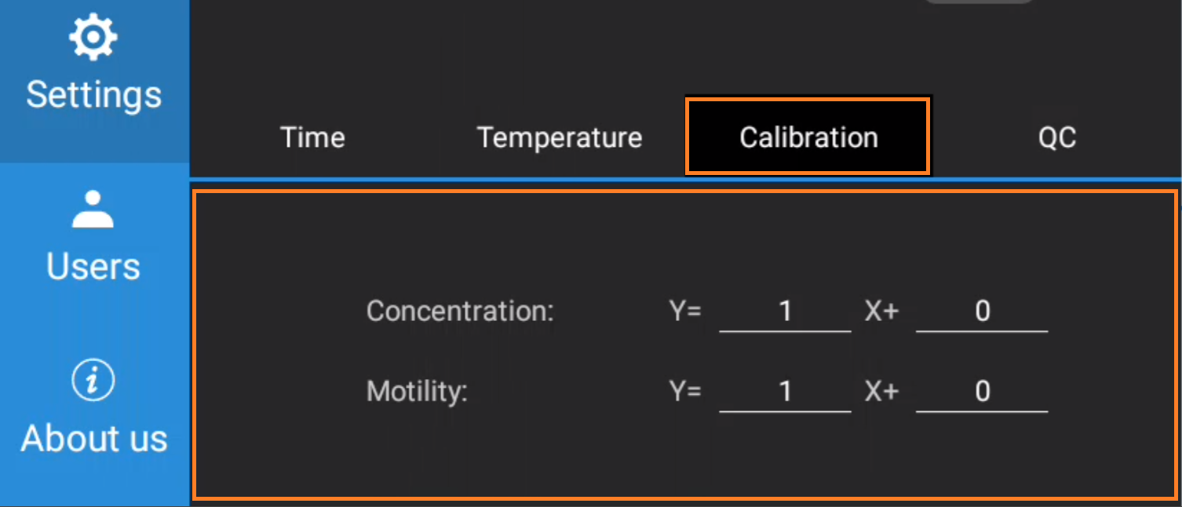

Figure 18. Settings menu/ Calibration
In QC section, the QC test using Latex beads can be performed. More information at Calibration guide.

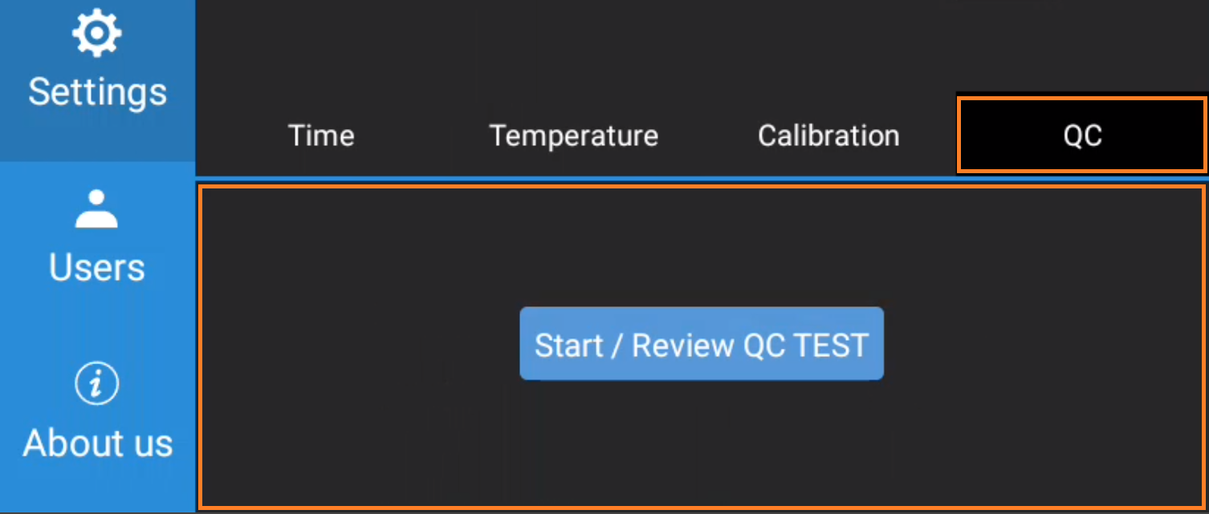

Figure 19. Settings menu/ QC

Analysis
For each of the modules of Nexus DX1, specific configuration can be modified in some parameters by the user.

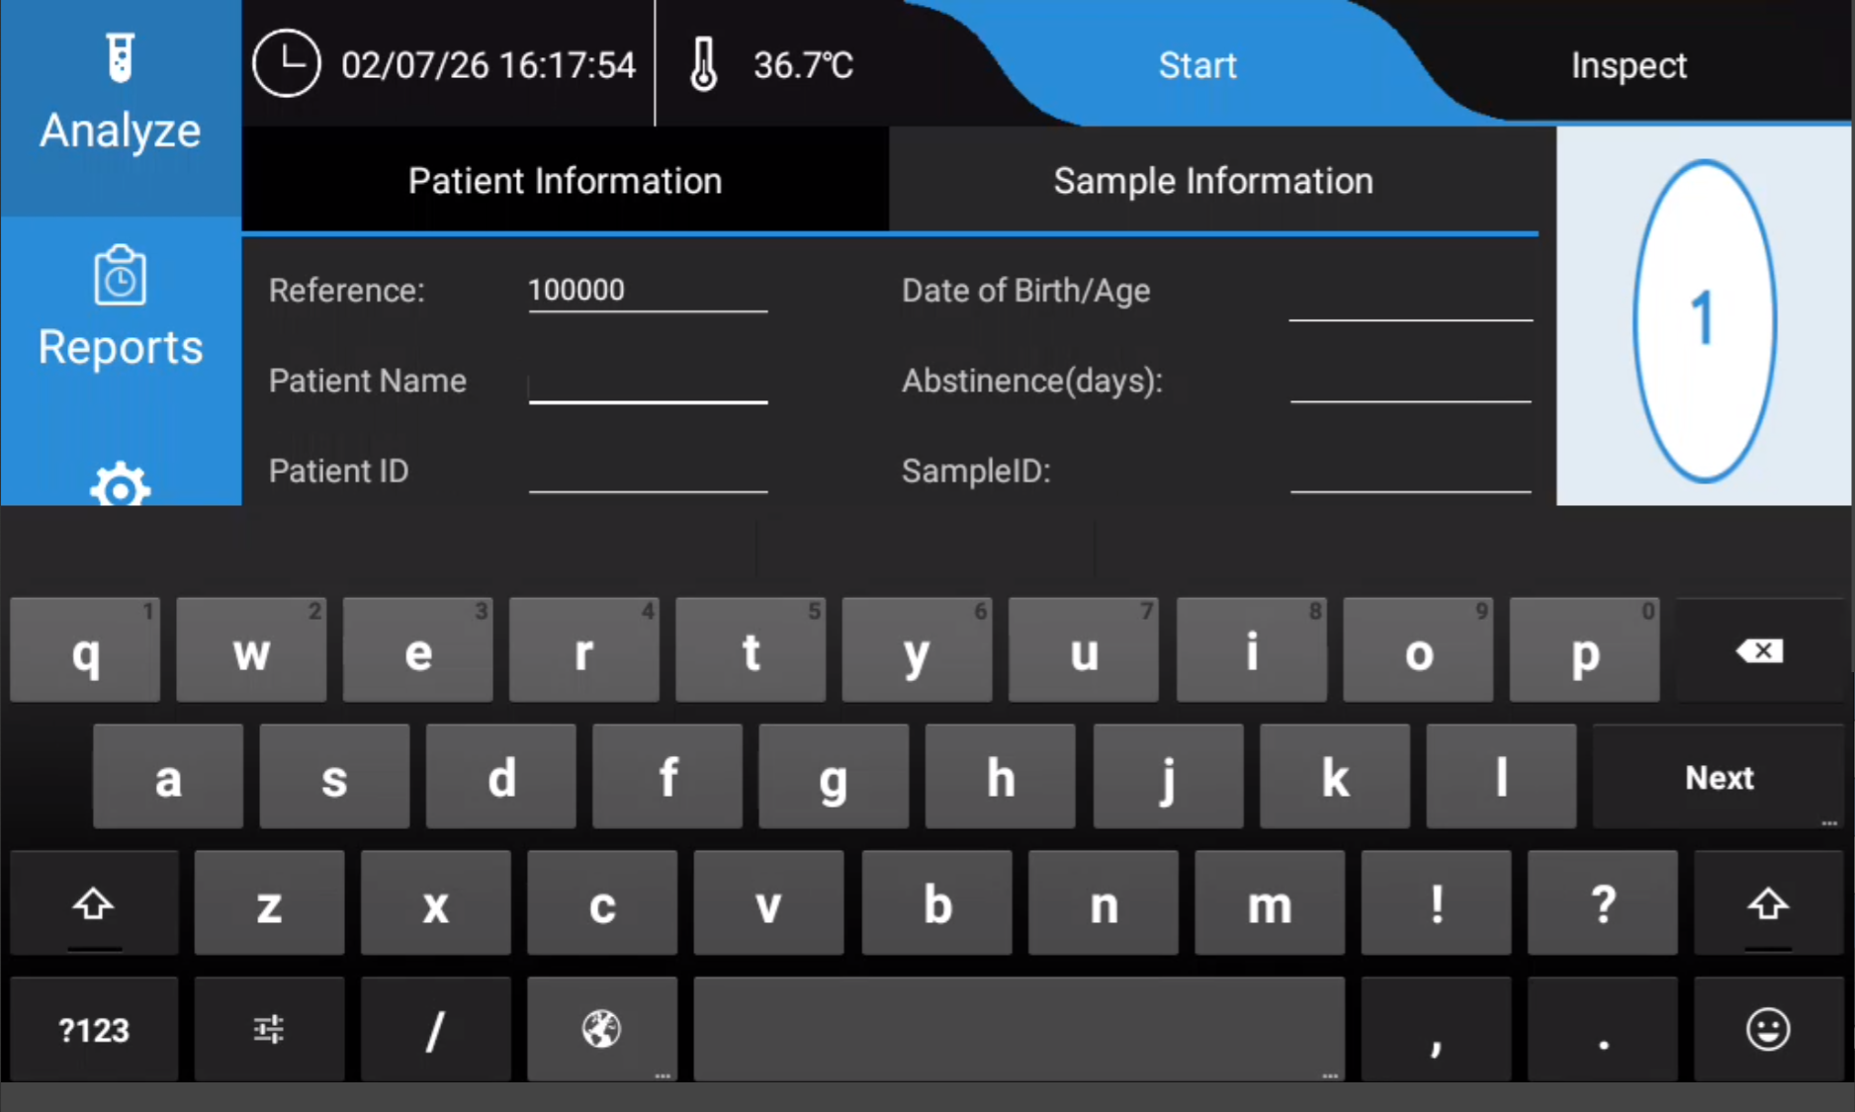
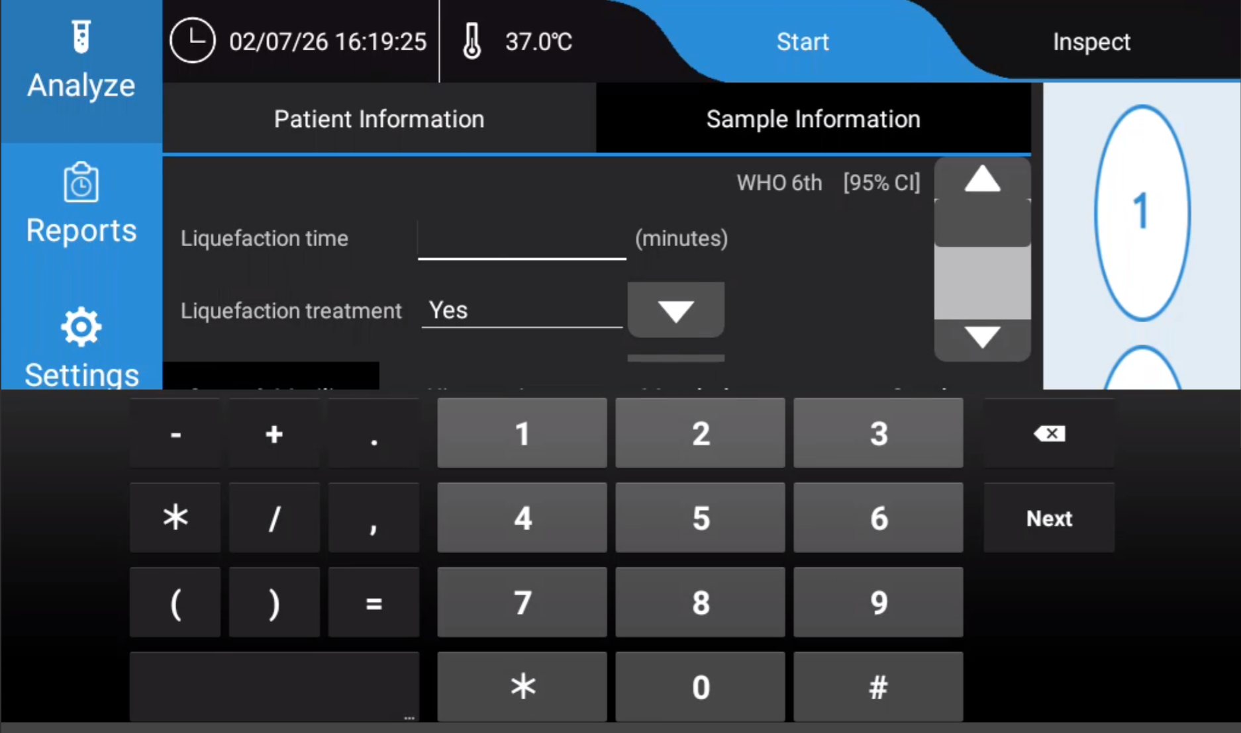

Conc. & Motility
Custom configuration
Open custom configuration: See detailed information about this section in 6.4.1.1 of SCA® User’s Guide 6.6.
Default disposable
  - Counting chambers SCA (10µm x2 pH)
  - Counting chambers SCA (10µm x4)
  - Counting chambers SCA (10µm x6)
  - Counting chambers SCA (20µm x2)
  - Counting chambers SCA (20µm x6)
Analysis options
Intelligent Filter: Correction filter that enables to eliminate the particles of the seminal plasma that are computed as sperm. When this option is enabled, SCA SCOPE will apply the filter automatically when each field is analysed. It is a useful tool for difficult samples containing high debris concentration. It is switched on by default.
Close Sperm Filter: Correction that deletes sperms that are placed too close in the field, during morphology analysis.
Agglutination Filter: Correction filter that enables to eliminate the agglutinations of the seminal plasma that are computed as sperm. When this option is enabled, SCA SCOPE will apply the filter automatically when each field is analysed. It is a useful tool for difficult samples that may have high viscosity.
Automatic checks
Focus: If the system detects that a captured field is out of focus, it is automatically deleted.
Image Color: Colour of fields is checked in order the background colour to be optimum for the analysis.
Concentration: A warning is shown when sperm concentration is higher than 100 M/ml (>300 sperms/field). At this point, sample needs to be diluted in order to avoid overlapping of sperm tracks, and Dilution Factor needs to be indicated (please see section “New analysis” in chapter 6.3 of the current guide).
Homogenous Fields: The system checks the variance between the captured fields and automatically eliminates the ones with >20% difference compared to the average of the sample (following WHO guidelines).
Perform autofocus for each field: The system focuses for every field with the x10 objective.
Auto-learn focus(*)
Automatically memorize focus from positions from previous analysis. This setting will improve analysis time. This feature can be switched on or off, and it is also possible to click “Reset focus position” to forget these values.
(*) Only available when Advanced Settings are enabled (see section 7.1).
Thermal stage
This parameter allows to change the temperature that will be set during MOT analysis between 20 and 40 °C or to disable the thermal stage, if you prepare to work at room temperature.
Reset configuration to default values (*)
Reset configuration will restore all parameters that could have been modified by the user in this configuration to their default values.
Compare with default configuration (*)
Allows to compare settings that could have been modified to the default ones.

Figure 20. Compare with default configuration

Figure 21. Settings menu – Motility analysis

Morphology
Custom configuration
Open custom configuration: See detailed information about this section in 7.4.1.1 of SCA® User’s Guide 6.6.

Analysis mode
Express: it analyses all the spermatozoon in the field. For this analysis, it is recommended not to analyse sperm tails because they could be out of the field, but to add them later manually if needed. In case tails are not analysed, TZI could not be trusted, since sperm tail defects are not considered.
Detailed: it takes every captured spermatozoon to the centre of the image. This analysis is optimal for analysis of sperm tails, as each sperm is entirely shown in the field.
Perform autofocus for each field: with the x10 objective.
Perform autofocus for each sperm: with the x60 objective.
Maximum analysis duration (min.): once the selected time runs out, the analysis is finished and results are shown.
Reset configuration to default values (*)
Reset configuration will restore all parameters that could have been modified by the user in this configuration to their default values.
Compare with default configuration (*)
Allows to compare settings that could have been modified to the default ones.

Figure 22. Settings menu – Morphology analysis

Vitality
Custom configuration
Open custom configuration: See detailed information about this section in 9.4.1.1 of SCA® User’s Guide 6.6.
Maximum analysis duration (min.): once the selected time runs out, the analysis is finished and results are shown.
Perform autofocus for each field: with the x10 objective.
Reset configuration to default values (*)
Reset configuration will restore all parameters that could have been modified by the user in this configuration to their default values. Compare with default configuration (*)
Allows to compare settings that could have been modified to the default ones.

Figure 23. Settings menu – Vitality analysis

DNA Fragmentation
Custom configuration
Open custom configuration: See detailed information about this section in 8.4.1.1 of SCA® User’s Guide 6.6.
Default disposable
  - Goldcyto Sperm DNA
  - Halosperm DNA
Perform autofocus for each field: with the x10 objective.
Reset configuration to default values (*)
Reset configuration will restore all parameters that could have been modified by the user in this configuration to their default values.
Compare with default configuration (*)
Allows to compare settings that could have been modified to the default ones.

Figure 24. Settings menu – DNA Fragmentation analysis

Leukocytes
Custom configuration
Open custom configuration: See detailed information about this section in 11.4.1.1 of SCA® User’s Guide 6.6.

Reset configuration to default values (*)
Reset configuration will restore all parameters that could have been modified by the user in this configuration to their default values.
Compare with default configuration (*)
Allows to compare settings that could have been modified to the default ones.

Figure 25. Settings menu – Leukocytes analysis

DataShare
Configuration options for sharing the data of SCA SCOPE. This module is always included in SCA SCOPE.

Database
Configure the database to a server for sharing it with other devices.
Server
IP of the server where SCA SCOPE database will be configured. If fields are empty, database is local.
Database Name
It is SCA6 by default, but it can be modified.

User
Username to have access to the server.
Password
Password to have access to the server.

Figure 26. DataShare menu – Database window

Export
From this section, it is possible to configure the system to automatically export sample reports and individual analysis reports to a folder selected by the user. These reports can be saved in different formats: PDF, XML, DOC, XLS.
In addition, images and videos can be automatically exported in a selected folder. These can be obtained in the following formats: JPG, AVI and AVI + tracks.

Figure 27. DataShare menu – Export window

HL7
Connect SCA SCOPE with LIS (Laboratory Information System) to transfer information about samples and patients in a bidirectional way using HL7.
From SCA to LIS
Enable this option to send sample/analysis results using HL7 from SCA to your LIS.
The transference of information from SCA to LIS can be done every time user saves the sample, otherwise user manually sends results with Transfer button.
It is required to configure LIS IP, LIS Port, LIS Name and LIS Directory. In addition, there is the option to use First Name^Last Name order.
From LIS to SCA
Configure SCA SCOPE to receive incoming HL7 messages from your LIS. This will enable your LIS to create the sample references and patients in SCA systems. Then, these references will automatically appear in the “Pending list” of analyses for each module of SCA SCOPE.
It is required to configure SCA Port, SCA Name and SCA Directory.

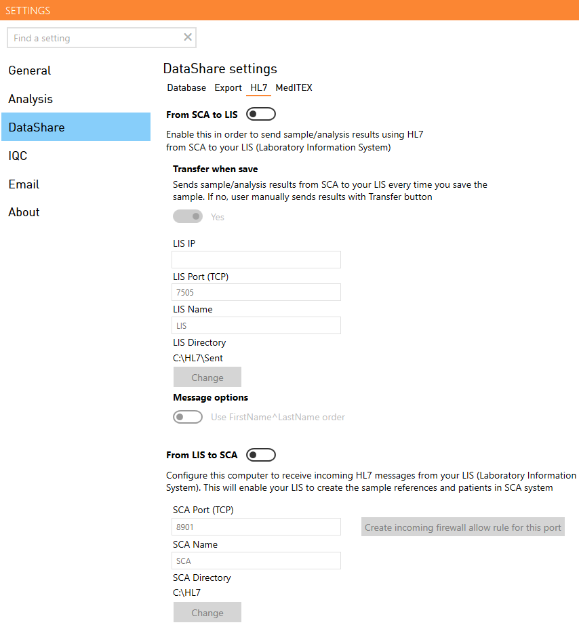

Figure 28. DataShare menu – HL7 window

MediTEX
Enable this option in order to send sample / analysis results to MediTEX and use their patient database.
It is required to configure MediTEX Server IP, Port and Charset. In addition, there is the option of sending analyses images.

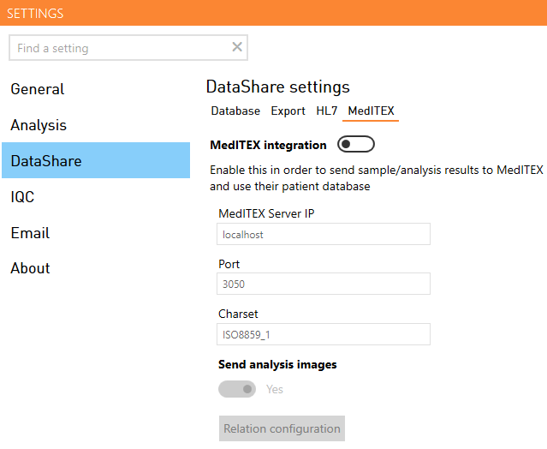

Figure 29. DataShare menu – MediTEX window

IQC
In this section there is the set of stored images that are analysed when performing an Internal Quality Control. These sessions can be opened or deleted. In case analysis configurations are changed, results of IQC sessions should be recalculated. On the other hand, custom IQC can be deleted to restore the factory default IQC.
QC-Beads settings
Auto focus sensibility: This parameter can be adjusted while system performs auto focus. Higher values correspond to a more comprehensive focus, while smaller values make auto focus more sensible, making it stop sooner.

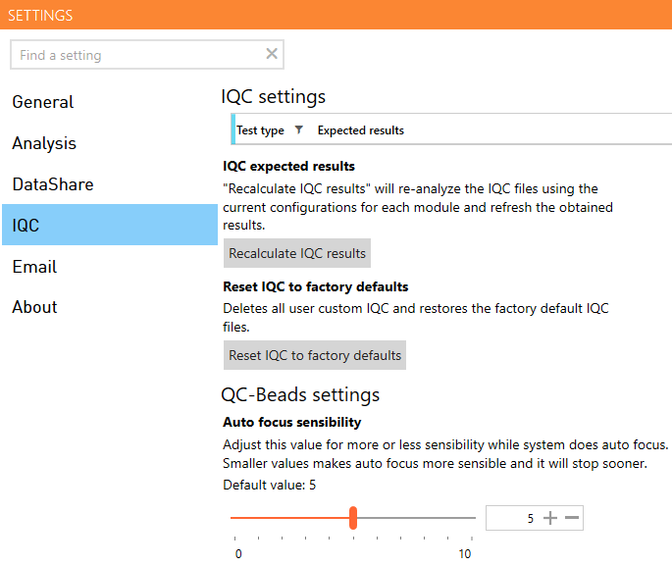

Figure 30. IQC Settings

Email
Configuration options to set up an e-mail account.
SMTP email server address
SMTP email server port
This value depends on the type of the email used (office 365, Gmail…). It can be easily found on Internet.
Email server use SSL (encrypted connection)
Username
Username of the user’s email.
Password
Password that user uses to log in in their email.
From email address
User’s email account from which the email will be sent.

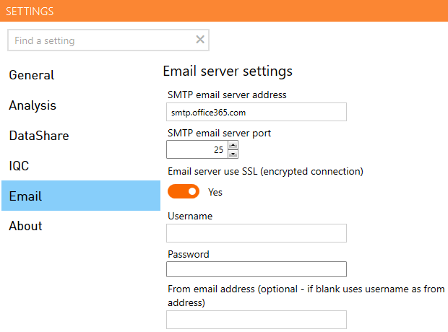

Figure 31. Settings menu – Email

Demo
“Reset demo” will restore all analysis configurations and database to the default values in case some parameters have been modified. This window is only shown when Demo mode is activated in SCA SCOPE (from Maintenance settings).

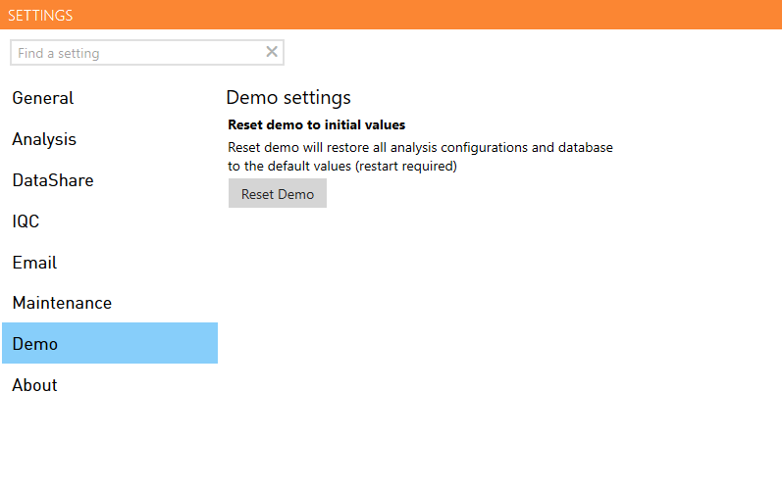

Figure 32. Settings menu – Demo

About
Basic information about SCA SCOPE.

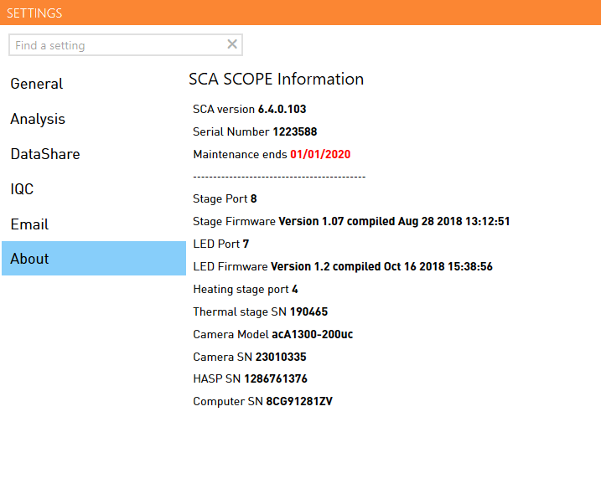

Figure 33. Settings menu – About



